Article 15 — The Evaluation Layer
Michal Doroszewski

The Broken Thermostat
You walk into a hotel room. It’s freezing. You tap the thermostat. It says 72°F. You raise it to 75. Nothing happens. You lower it to 65. Still nothing. You press “Fan.” The screen flashes, then resets. You press “Heat.” The screen says “Mode not supported.” You press “Auto.” The screen says “Sensor error.”
You call the front desk. They say, “It’s centrally managed. Try again.” You try again. The screen now says “Evaluating…” and then resets. You try again. It says “Posture unknown.” You try again. It says “Location mismatch.” You try again. It says “Risk elevated.” You haven’t moved. You haven’t changed. You haven’t done anything except ask the system to evaluate the situation and respond.
The thermostat isn’t broken. It’s confused. It cannot evaluate the inputs. It cannot trust the signals. It cannot decide what to do. It resets. It stalls. It denies. It contradicts itself.
That is the Evaluation Problem — not the “bad policy” kind, but the architectural kind. The kind that appears when cloud systems cannot reliably evaluate trust, posture, location, and risk in real time. The kind that turns a thermostat into a guessing machine.
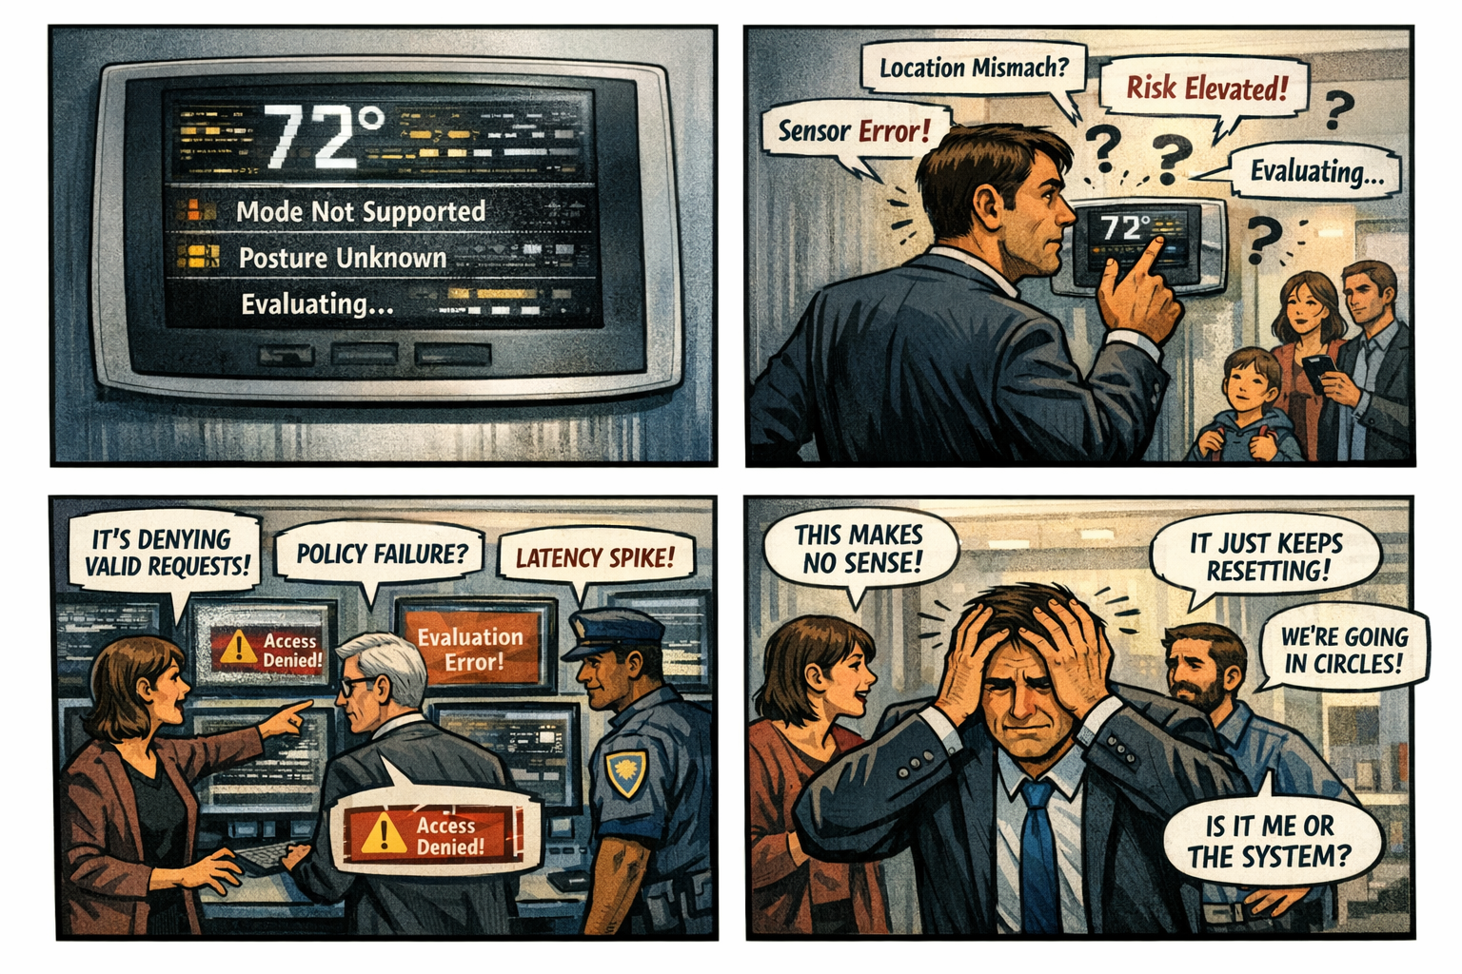

Evaluation Is the Fifth Layer of Modernization
Visibility shows what is happening. Continuity stabilizes identity across transitions. Control determines what the system is allowed to do. Signals carry the truth. But evaluation decides what happens next.
Modern identity platforms rely on real‑time evaluation of posture, location, risk, compliance, and session context. These evaluations must be fast, complete, and consistent. When they are delayed, distorted, or partial, the system does not fail. It misfires. It contradicts itself. It denies access. It resets trust. It stalls modernization.
A system that cannot evaluate cannot decide. A system that cannot decide cannot function.

Why GCC‑Moderate Breaks Evaluation
The FedRAMP Moderate boundary was built for static policy, not dynamic evaluation. It filters the signals. It delays the timing. It distorts the context. It mislabels the location. It fragments the truth.
The evaluation engine receives partial input. It sees posture but not location. It sees risk but not session context. It sees the device but not the refresh signal. It sees the user but not the compliance state.
The system is not rejecting the user. It is rejecting the uncertainty.
Evaluation fails not because the policy is wrong, but because the architecture blocks the truth required to apply the policy.

Headquarters and Field Offices Experience Evaluation Differently
At headquarters, evaluation is fast and complete. Signals arrive intact. Context is preserved. Decisions are consistent.
In field offices, evaluation is slow and partial. Signals arrive late. Context is distorted. Decisions are contradictory.
The same user, same device, same request — different evaluation. The architecture creates two realities, and the system enforces both.

Why Evaluation Failures Are Misdiagnosed
When evaluation collapses, every team sees a different symptom.
Security sees policy misfires. Identity sees token resets. Network sees latency. Operations sees region drift. Users see random denials.
Everyone is correct. Everyone is wrong.
The failure is architectural. The system cannot evaluate because the signals required to evaluate never arrive intact.

Modernization Stalls Without Evaluation
Without reliable evaluation:
conditional access contradicts itself
device trust misclassifies
location mislabels
risk fluctuates
sessions reset
policies deny valid users
teams chase phantom misconfigurations
This is not a governance problem. It is architectural indecision.

The Root of the Evaluation Problem
The evaluation problem is not caused by bad policy, misconfigured rules, incorrect groups, or user error. It is caused by an architecture that cannot reliably deliver the truth required for dynamic evaluation.
The boundary filters the truth. The WAN delays the truth. The inspection layers distort the truth. The region model mislabels the truth. The identity platform receives partial truth.
A system cannot evaluate with partial truth. A system cannot decide inside a fog.

The Only Way Forward
Evaluation must be restored.
The boundary must allow identity‑critical signals. Timing must be preserved. Region awareness must be accurate. Device posture must be current. Risk evaluation must be complete. Session context must be intact. Policy logic must receive the full truth.
Only then can decisions be consistent. Only then can enforcement be predictable. Only then can modernization move forward without contradiction.

Disclaimer
Not all agencies will experience the issues described in this article. These behaviors occur primarily in architectures where cloud identity, Conditional Access, and real‑time policy evaluation depend on signals that traverse GCC‑Moderate boundaries, WAN inspection layers, or region‑variable paths. Agencies that rely on direct Active Directory authentication, maintain on‑premises identity controllers, or operate with short, stable network paths may see different outcomes. These observations reflect common patterns in GCC‑Moderate cloud environments, not universal conditions.

About the Author
Michal Doroszewski is a technology strategist focused on cloud architecture, identity platforms, and federal modernization. He writes about the structural and architectural forces that shape government IT, translating complex technical constraints into clear, accessible narratives for leaders and practitioners.

